**PFue-II MANUAL**

**Tested Operating System:** Windows 10 (64 Bit)

**Needed Software:** (Must install before using PFue-II)

* Pylon 5.0.12 Camera Software Suite Windows

Download Link: <https://www.baslerweb.com/en/sales-support/downloads/software-downloads/pylon-5-0-12-windows/>

**Setup Guide:**

1. Connect all wires between robot and PC/laptop
2. On PC/laptop >> set serial ports

“COM8” for USB2Dynamixel

“COM18” for ArduinoNANO

**User Guide:**

1. Open the “PFue-II” program

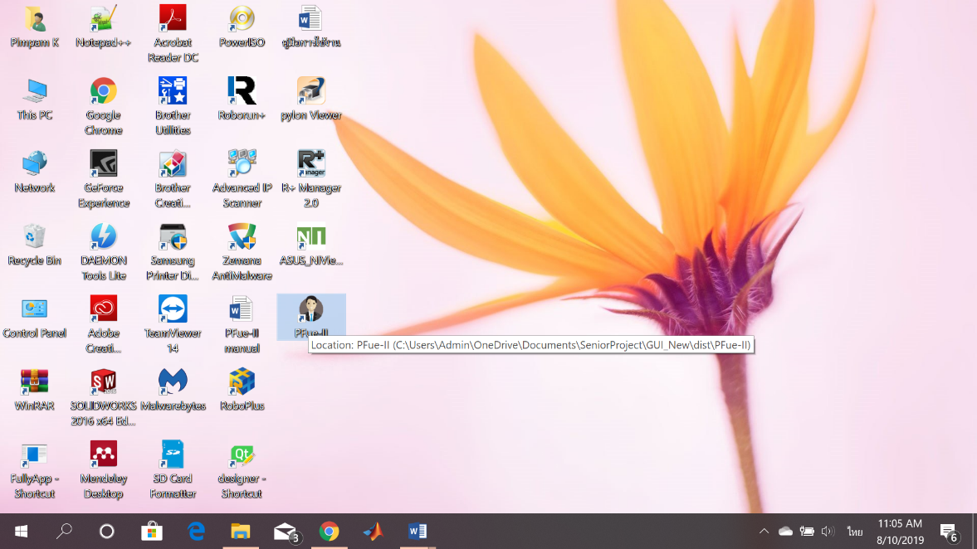

1. Input a patient’s info including name, surname, and HN no.

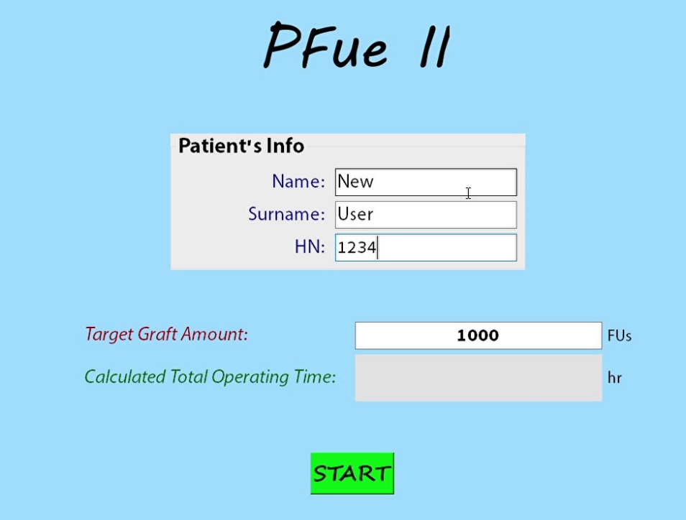

1. Input a target graft amount (unit: FUs), then press “Enter” on your keyboard (The system will calculate approximate total operating time in hour unit for the input target amount

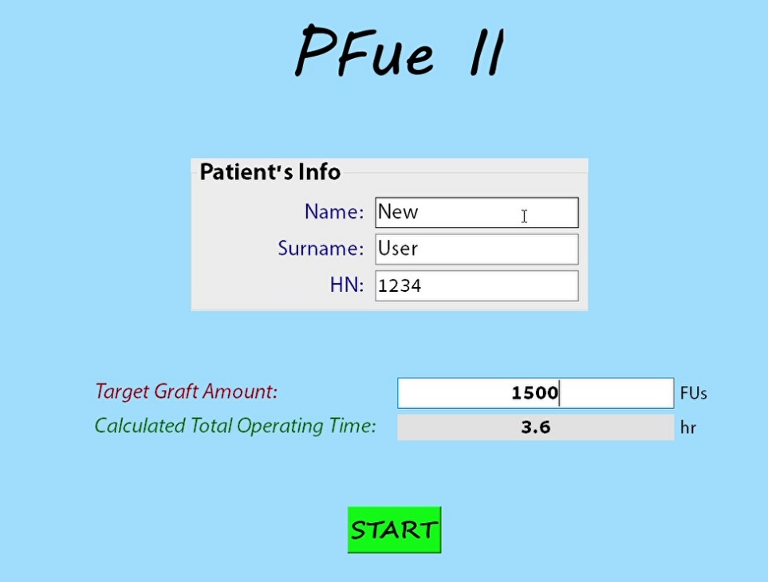

1. Click on a “START” button and follow dialogs that will pop up on the screen

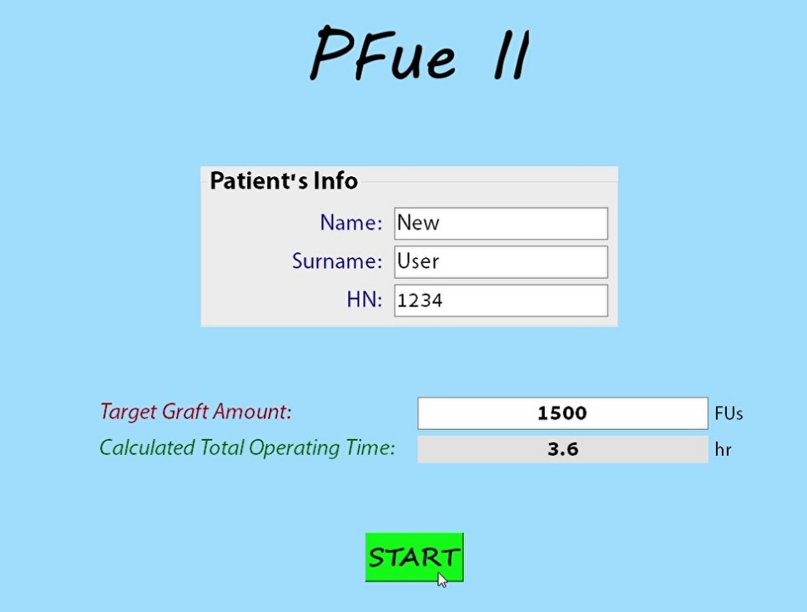

1. Then, the main window will show up

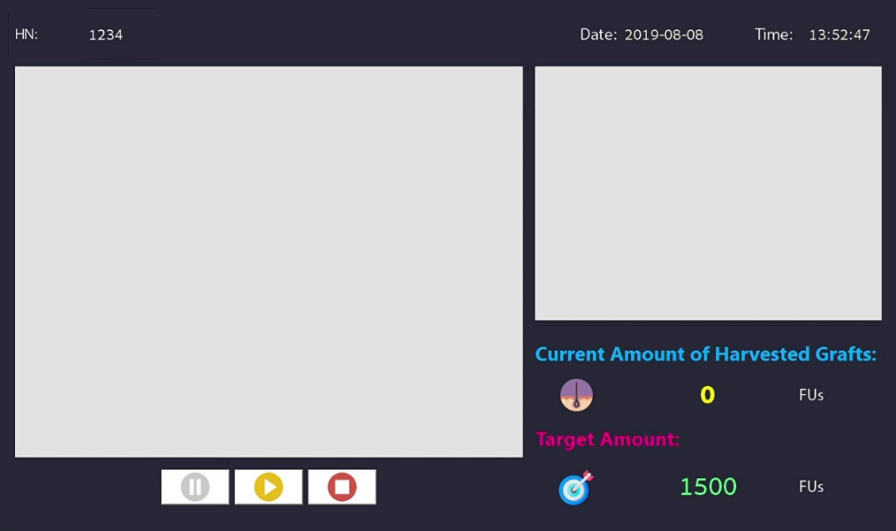

1. Click on a play sign (yellow) button on at the bottom of the main window to start the process (there are warning dialogs pop up before start the process)

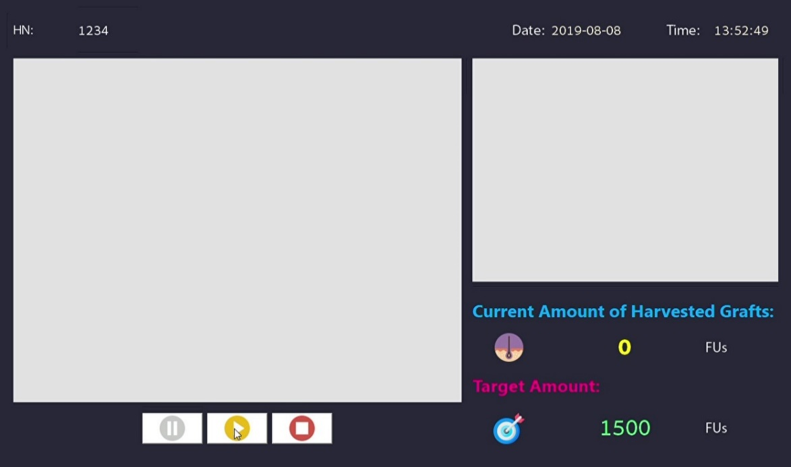

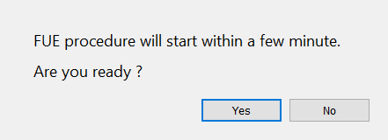

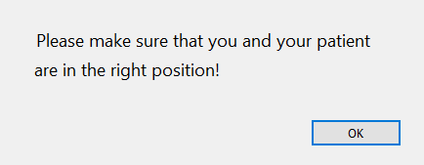

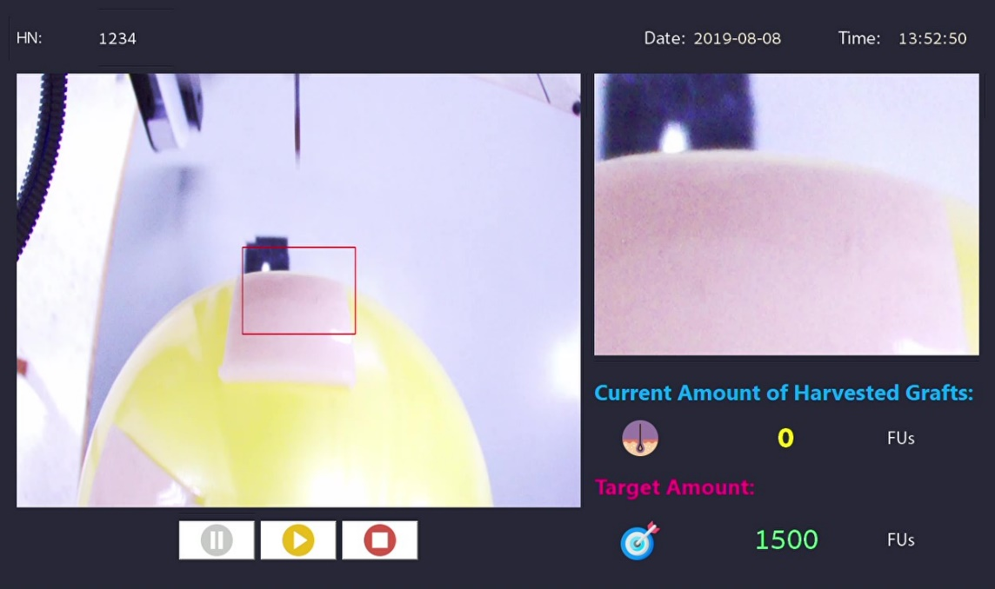

1. To pause the camera view, click on the pause sign (gray) button
2. To stop the process and quit the program, click on the stop sign button and follow the pop-up dialogs.

